Lab #8: Design of a Traffic Controller
By: Anaya Scott and Carol Morales
ECE3441 FA25

Part 1: Traffic Light Specifications and Design Choices
Questions:
- Sketch the intersection with the six traffic lamps. Label the street names and the R, G, and B lamps for each direction.
  - 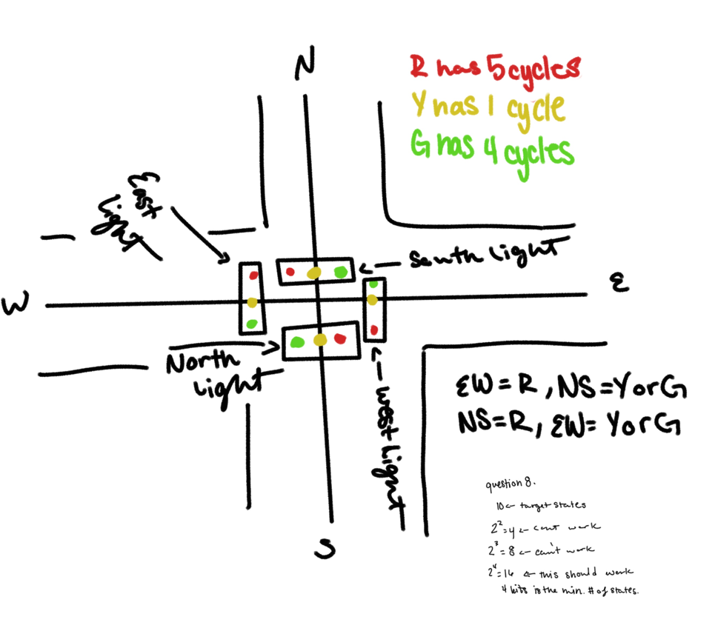
- Using the description above, create a table that shows the state of the six lamps at each of the 10 clock cycles. Since you do not know the states yet, just label each row 1-10.
  - 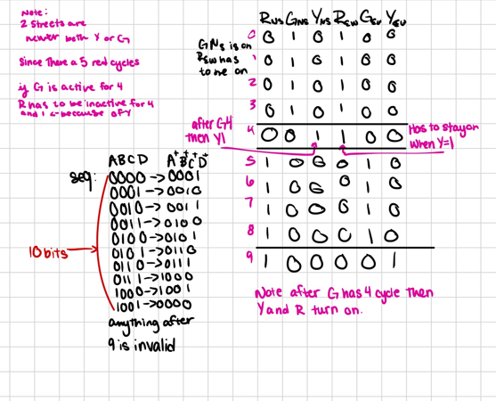

Part 2: The 8-bit Approach
3. How many flip-flops (of any variety) are required to store the 8-bit state?
a. You would need 8 flip flops, one for each bit.
4. How many rows would your full transition table have?
a. A full transition table would be 2^8 = 256 rows.
5. How many unused states are there?
a. Since we are look for 10 state cycle, so we can do 256 – 10 = 246 unused states.
6. Imagine that when you power up your circuit, the starting state is random. What’s the
percentage chance that your controller misses your 10 used states? What dangers does this pose, and how would you try to fix it?
a. $\frac{246}{256}*100=96.093\%$. This makes the controller very dangerous as it would mostly get stuck in an invalid state. Leading the lights to be in green at the same time. Generally, machines like traffic lights are designed to have a valid state, that allows the detection of unused states and reset the light to a valid state.
7. Considering the number of variables/combinations, do you think that designing an optimized circuit is practical?
a. No, I think that it would be very impractical to use this method as the number of combinations is very high.

Part 3: Minimal State Bits Approach, Version I
8. What’s the minimum number of state bits required to support the 10-traffic controller states?
The minimum number of state bits would have to be 4 bits because 2^3 = 8 isn’t sufficient for the controller to work but 2^4= 16 would be enough for the controller to work.
9. How many rows will the transition table contain?
The table would consist of 16 rows as it’s the 16 possible outcomes from the 4-bit minimum.
10. This controller’s sequence counter will count from 0 to 9 in binary and repeat: 𝐴𝐵𝐶𝐷 = 0000 → 0001 → 0010 → 0011 →0100 → 0101 → 0110 → 0111 → 1000 →1001 →0000. Create a 16-row transition table. Add columns for each of the six traffic light lamps as well. Leave unused states as don’t-cares.

11. Using K-maps, solve for A+, B+, C+, D+, RNS, GNS, YNS, REW, GEW, and YEW as functions of 𝐴𝐵𝐶𝐷 given that YNS = 1 when 𝐴𝐵𝐶𝐷 = 0100. Show your work and place your formulas in a table.

Part 4: Minimal State Bits Approach, Version II
12. Create a 16-row transition table for your homemade states. Add additional columns for each of the six traffic light lamps. Leave the unused rows as don’t-cares.

13. Explain (with words) how to find the state of GEW given any state in your sequence.

14. Solve for A+, B+, C+, D+, RNS, GNS, YNS, REW, GEW, and YEW using K-maps. Show your work.

15. Does your Boolean algebra solution for GEW match your verbal explanation above?

16. Provide a circuit schematic for your solution.

17. Provide a timing diagram for ten clock cycles.

18. Was your solution better the one in Part 3? If not, try again! It will be worth it.

